Caroline Cliona Boyle

Data journalism

Prof. Minkhoff

**After Cop26, community action initiatives are upending the fashion industry**

Juliana Jaramillo is the founder of Circle Vibe DC, a community organization in Washington, D.C., that shares sustainability education. The collective organizes montly events that promote second-hand fashion, including swap-shops and workshops that educate locals about the exploitation of garment workers and the effects that fast fashion has on climate climate.

One of the primary intiatives that Jaramillo runs at Circle Vibe is the creation of a capsule wardrobe, which is a highly curated set of clothing items that provide a stable base, limiting the need to consume fashion products elsewhere, she says. At the swap-shops, fashion-savy locals can trade clothes between eachother, allowing people to indulge in their personal changing taste in fashion, without enlargening their carbon footprint.

This method of promoting sustainable fashion steers away from trends, a figment of the fashion industry rooted in capitalism. The consumption of second-hand at the local level, as presented at Circle Vibe DC, has exploded in popularity over the past 10 years.

Out of the category of second-hand products consumed by Americans in 2021, clothing presented the highest percentage. In total, 29% of Americans purchased second-hand clothing — a figure which amounts to over 100 million individuals.

<https://datawrapper.dwcdn.net/iIsFi/1/>

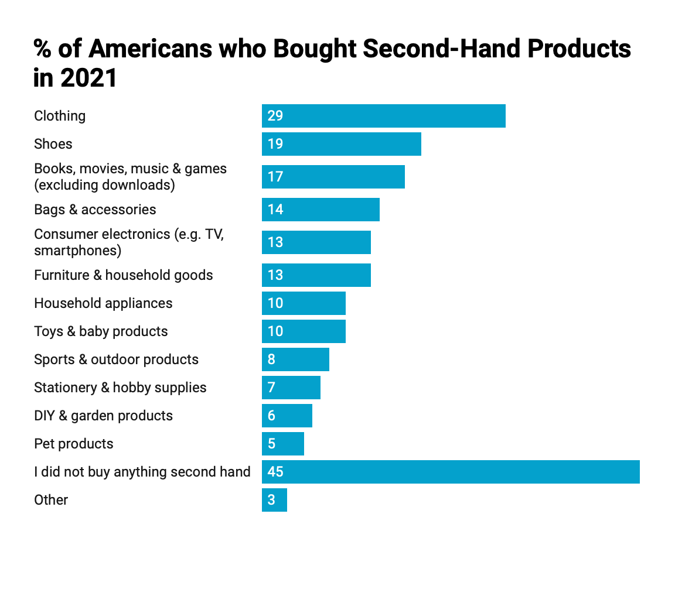

In the past 10 years, projections for the second-hand fashion industry have increased ten-fold. This is affirmed by the projections of the second hand apparel market in the U.S. By 2025, the second hand clothing market in the United States is expected to reach over $70 billion.

<https://datawrapper.dwcdn.net/GWoSj/1/>

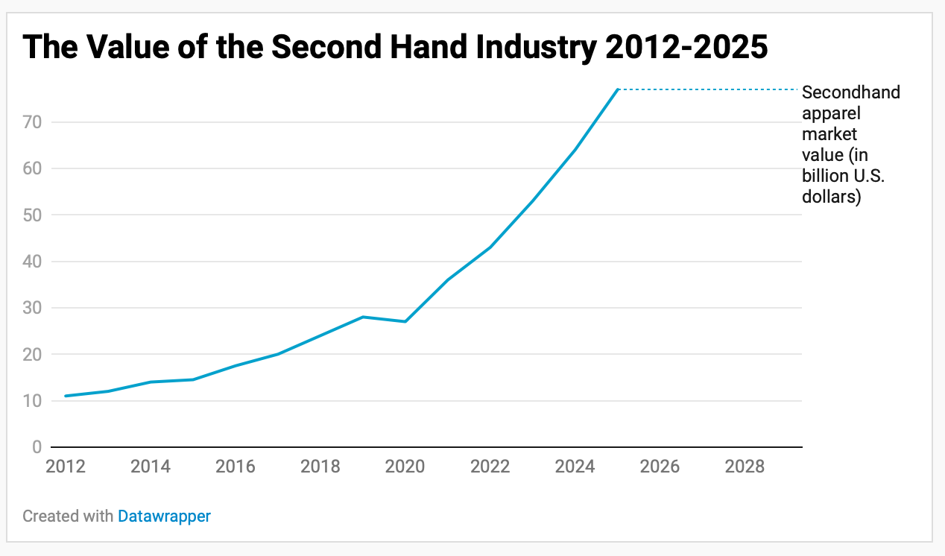

While buying second-hand is only one facet of the eco-conscious industry, it is a consumption habit that drastically minimizes individual carbon footprints.

Second Hand Market in the U.S. in 2021 by %

<https://www.statista.com/forecasts/997103/second-hand-purchases-by-category-in-the-us>

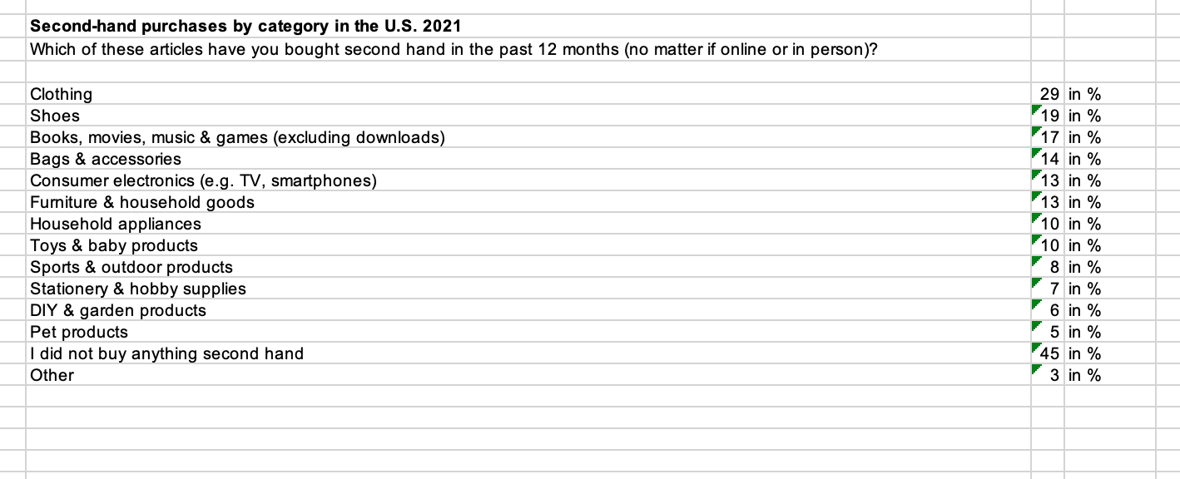

Second Hand Industry Value

<https://www.statista.com/statistics/826162/apparel-resale-market-value-worldwide/>

